Name: M.KASIF JALAL Reg No: 192424214 Course&Code: CSA1522 Cloud Computing & Big Data

EXP NO 12: Create a Virtual Machine with 1 CPU, 2GB RAM and 15GB storage disk using a Type 2 Virtualization Software, using virtual box.

Aim:
To create and configure a virtual machine with 1 CPU, 2 GB RAM, and 15 GB storage using VirtualBox as a Type-2 virtualization software.

Procedure:
Step 1: Open Oracle VirtualBox on the host computer.
Step 2: Select the already created Ubuntu VM and open Settings. Step 3: Go to System → Motherboard and set the memory to 2048 MB (2 GB).
Step 4: Go to System → Processor and set the processor count to 1 CPU.
Step 5: Open Storage and verify that the virtual hard disk is configured with 15 GB storage.
Step 6: Click OK, start the Ubuntu VM, and verify that it boots successfully.

IMPLEMENTATION:

Step 1: Open Oracle VirtualBox on the host computer.

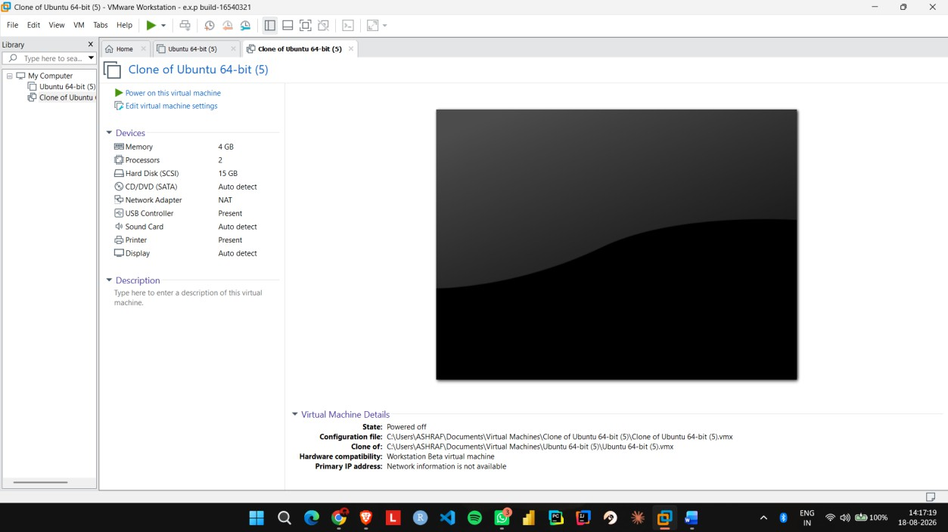
Step 2: Select the already created Ubuntu VM and open Settings.

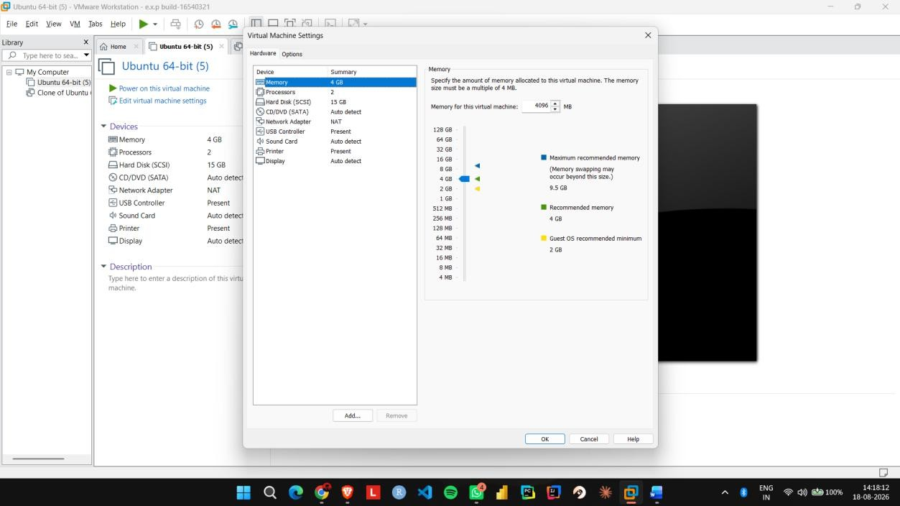

Step 3: Go to System → Motherboard and set the memory to 2048 MB (2 GB).

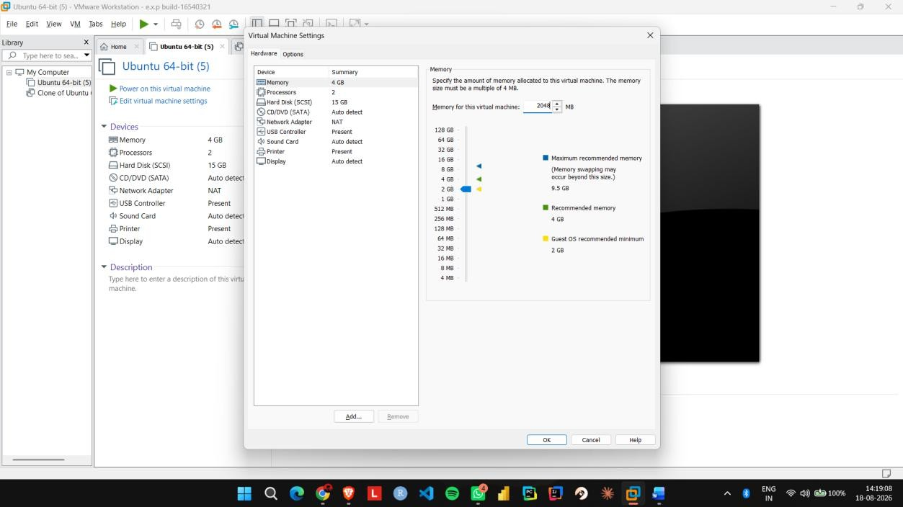
Step 4: Go to System → Processor and set the processor count to 1 CPU.
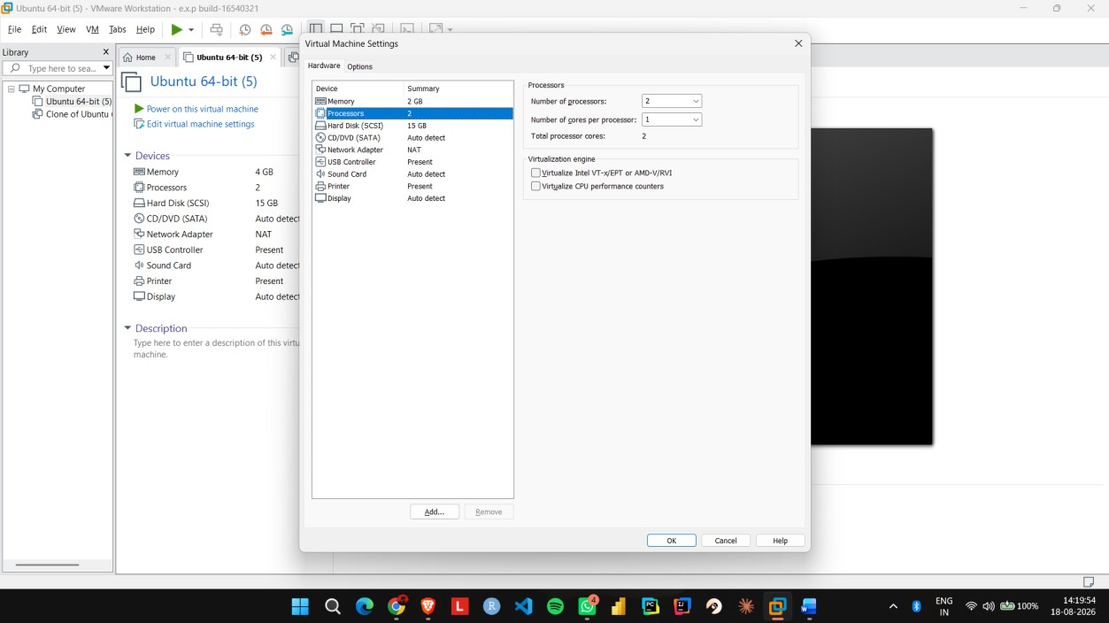

Step 5: Open Storage and verify that the virtual hard disk is configured with 15 GB storage.

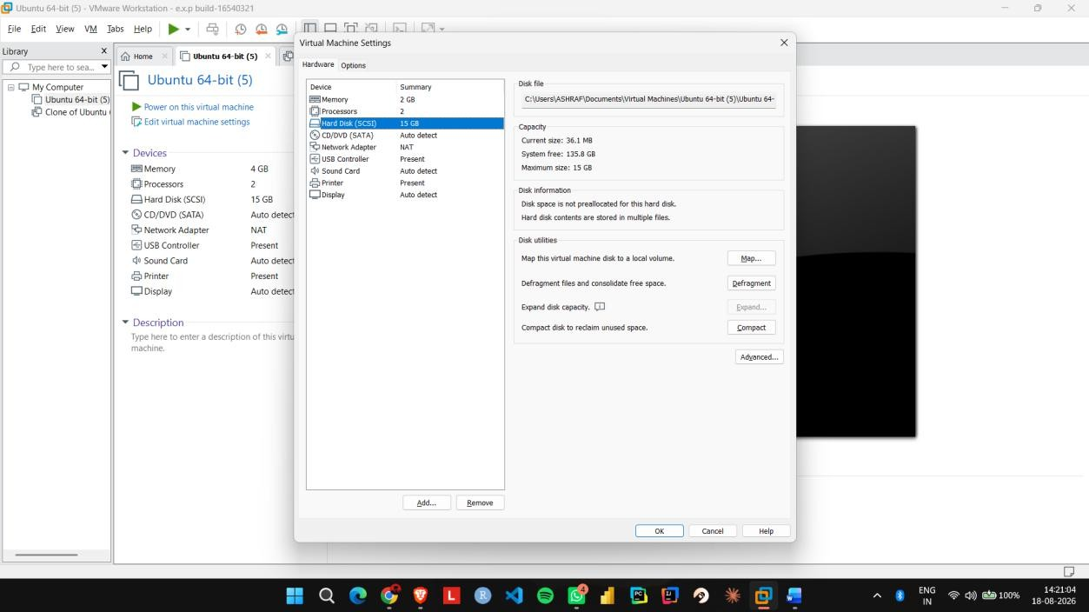
Step 6: Click OK, start the Ubuntu VM, and verify that it boots successfully.
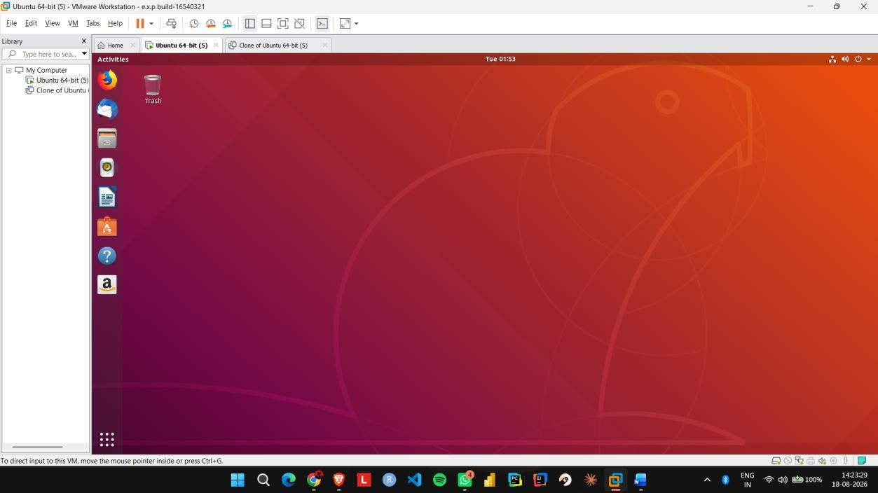

EXP NO 13: Create a Virtual Hard Disk and allocate the storage using virtual box.

Aim:
To create a virtual hard disk and allocate storage to it using VirtualBox.

Procedure:
Step 1: Open VMware Workstation and select the existing Ubuntu virtual machine.
Step 2: Click Edit virtual machine settings.
Step 3: Select Hard Disk and click Add to create a new virtual hard disk.
Step 4: Select Hard Disk → SCSI as the virtual disk type.
Step 5: Select Create a new virtual disk and allocate the required storage, such as 15 GB.
Step 6: Click Finish and verify that the new virtual hard disk is attached to the Ubuntu VM.
IMPLEMENTATION:

Step 1: Open VMware Workstation and select the existing Ubuntu virtual machine.

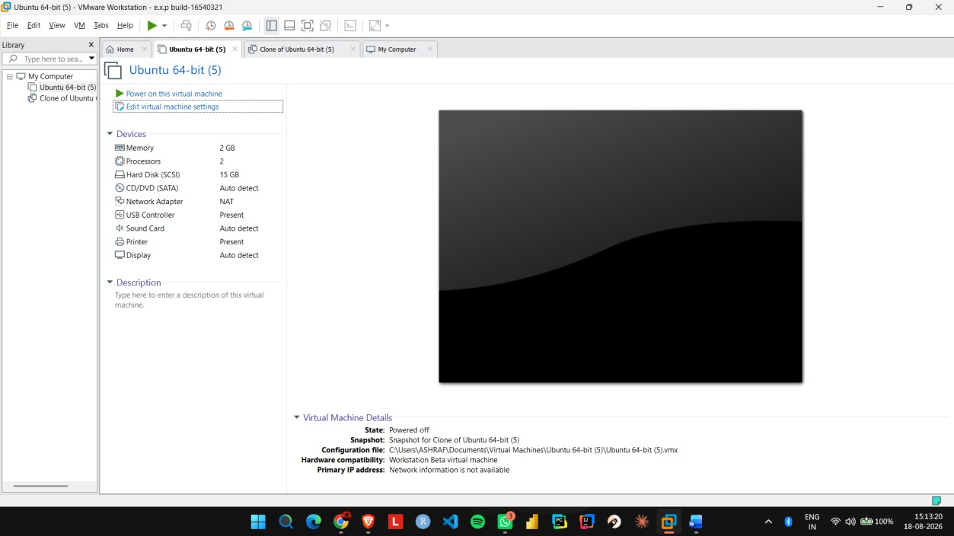

Step 2: Click Edit virtual machine settings.
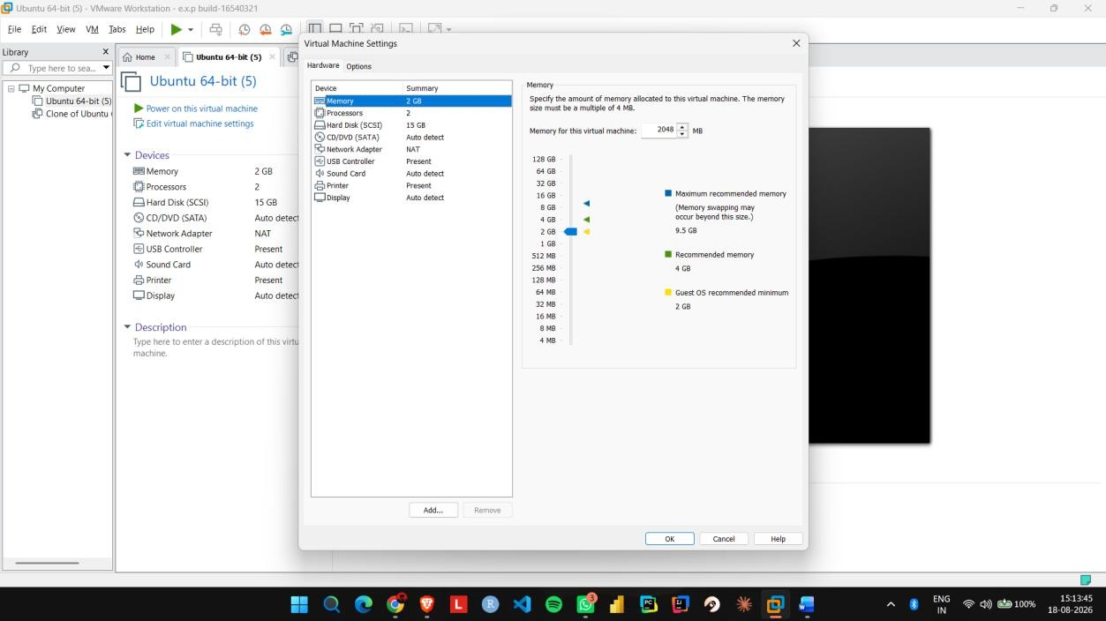

Step 3: Select Hard Disk and click Add to create a new virtual hard disk.

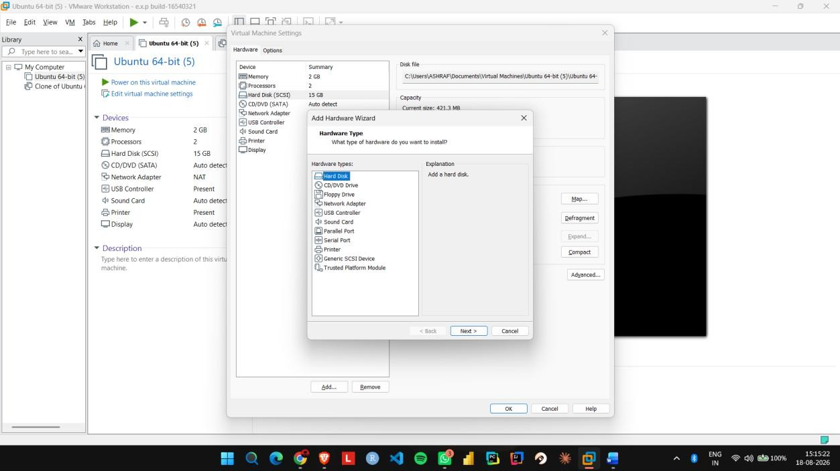

Step 4: Select Hard Disk → SCSI as the virtual disk type.
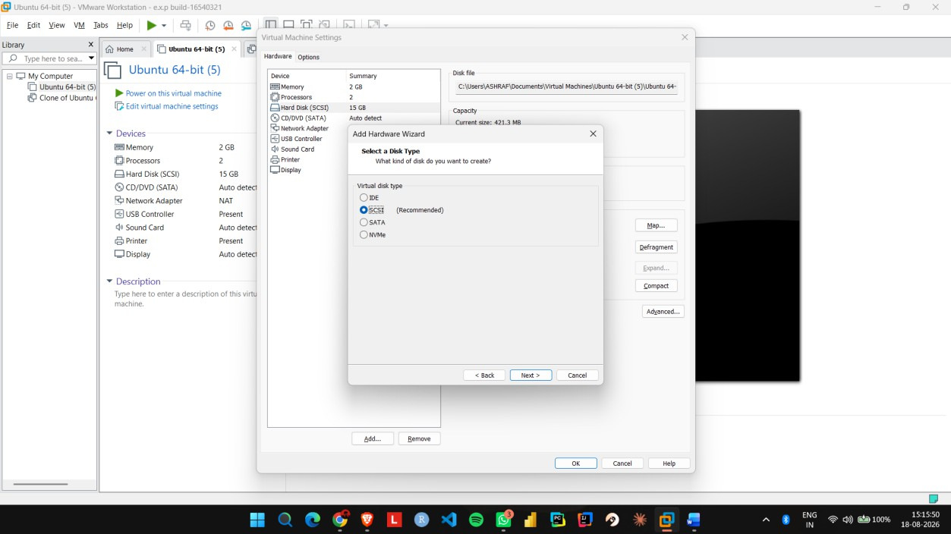

Step 5: Select Create a new virtual disk and allocate the required storage, such as 15 GB.
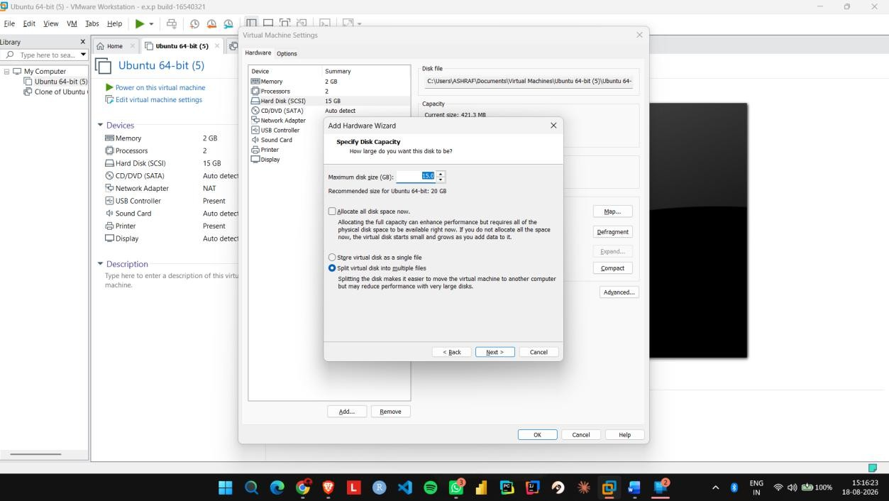

Step 6: Click Finish and verify that the new virtual hard disk is attached to the Ubuntu VM.
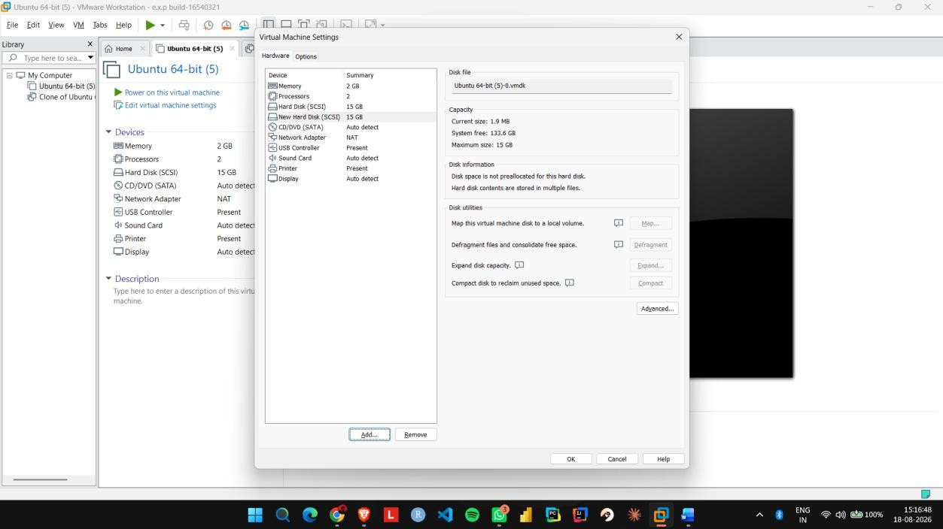

EXP NO 14: Create a Snapshot of a VM and Test it by loading the Previous Version/Cloned VM using a virtual box.

Aim:
To create a snapshot of a virtual machine and restore the previous version using VMware Workstation.

Procedure:
Step 1: Start the Ubuntu VM in VMware Workstation and create a test file or folder.
Step 2: Shut down or suspend the VM and open the Snapshot option.
Step 3: Select Take Snapshot and enter a name such as Before_Changes.
Step 4: Start the VM again and make some changes, such as creating a new file.
Step 5: Open Snapshot Manager, select
the Before_Changes snapshot, and click Go To/Restore.
Step 6: Start the VM and verify that the changes made after the snapshot have been removed.

IMPLEMENTATION:

Step 1: Start the Ubuntu VM in VMware Workstation and create a test file or folder.

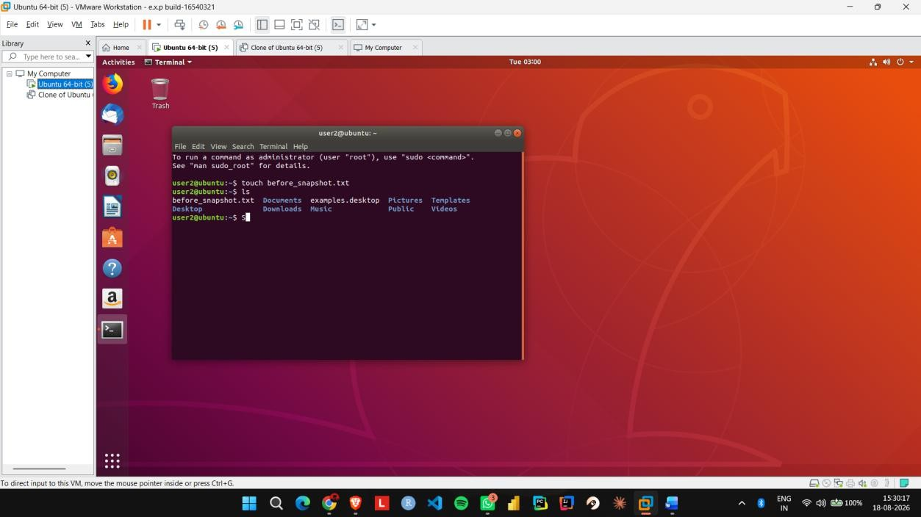

Step 2: Shut down or suspend the VM and open the Snapshot option.

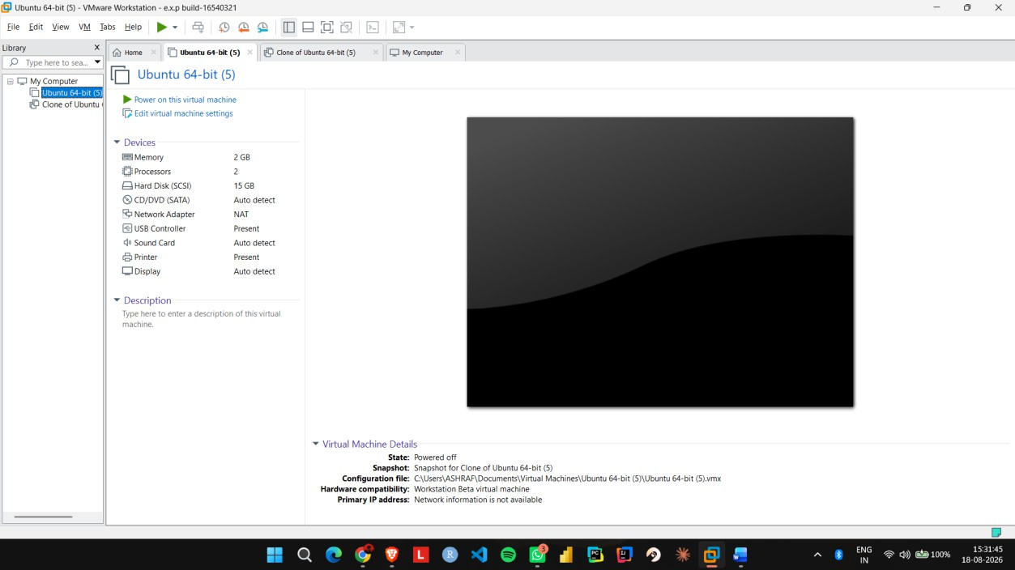

Step 3: Select Take Snapshot and enter a name such as Before_Changes.
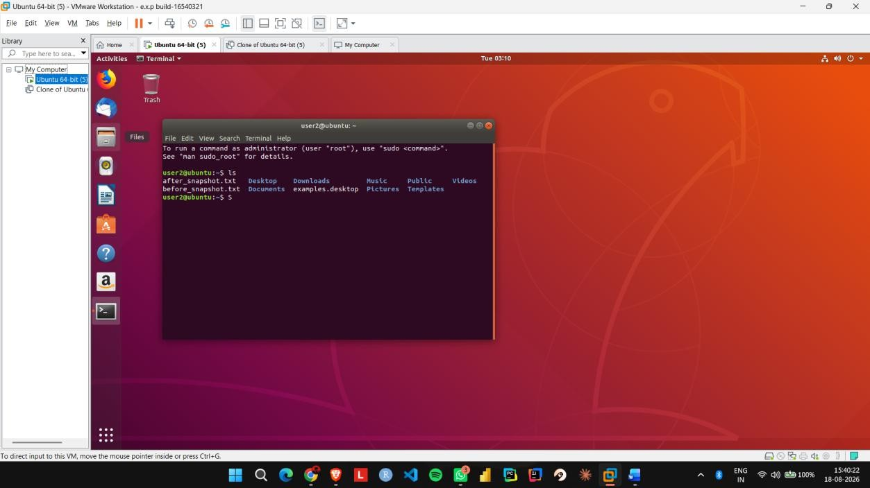

Step 4: Start the VM again and make some changes, such as creating a new file.
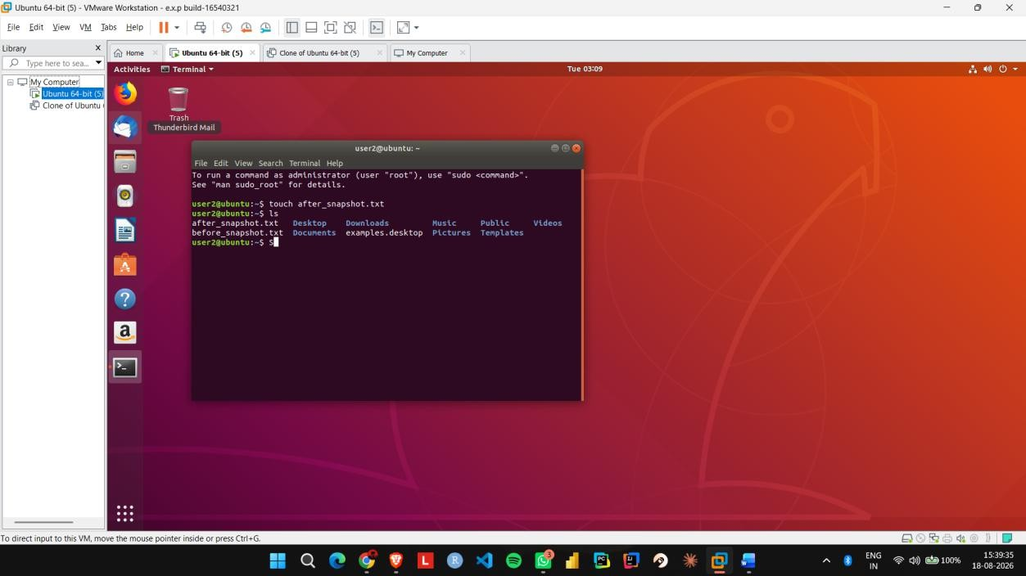

Step 5: Open Snapshot Manager, select
the Before_Changes snapshot, and click Go To/Restore.

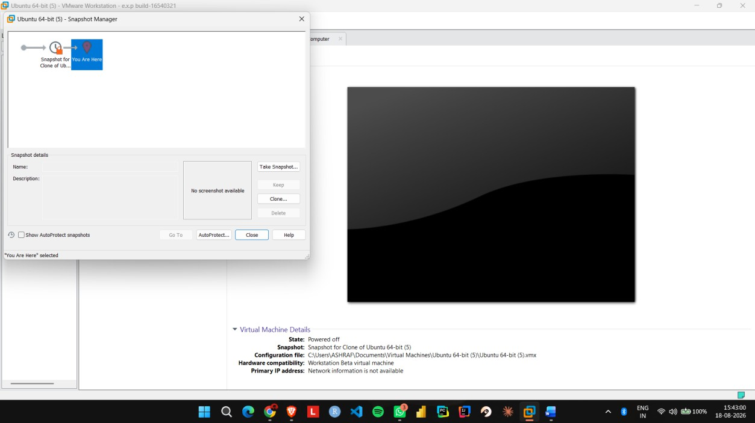

Step 6: Start the VM and verify that the changes made after the snapshot have been removed.
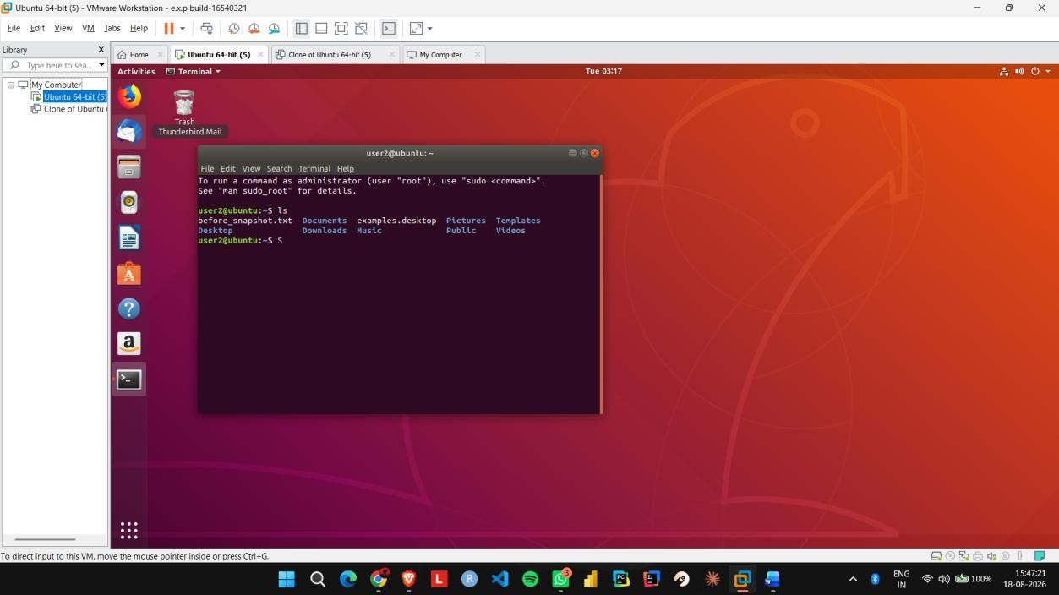

EXP NO 15: Create a Cloning of a VM and Test it by loading the Previous Version/Cloned VM using a virtual box.

Aim:
To create a clone of an existing virtual machine and test the cloned virtual machine using VMware Workstation.

Procedure:
Step 1: Shut down the existing Ubuntu VM completely.
Step 2: Open VMware Workstation and select VM → Manage → Clone.
Step 3: Select the current state of the virtual machine as the cloning source.
Step 4: Select Create a Full Clone and give the cloned VM a name such as Ubuntu_Clone.
Step 5: Complete the cloning process and start the Ubuntu_Clone virtual machine.
Step 6: Create a test file in the cloned VM and verify that it does not appear in the original Ubuntu VM.

IMPLEMENTATION:

Step 1: Shut down the existing Ubuntu VM completely.

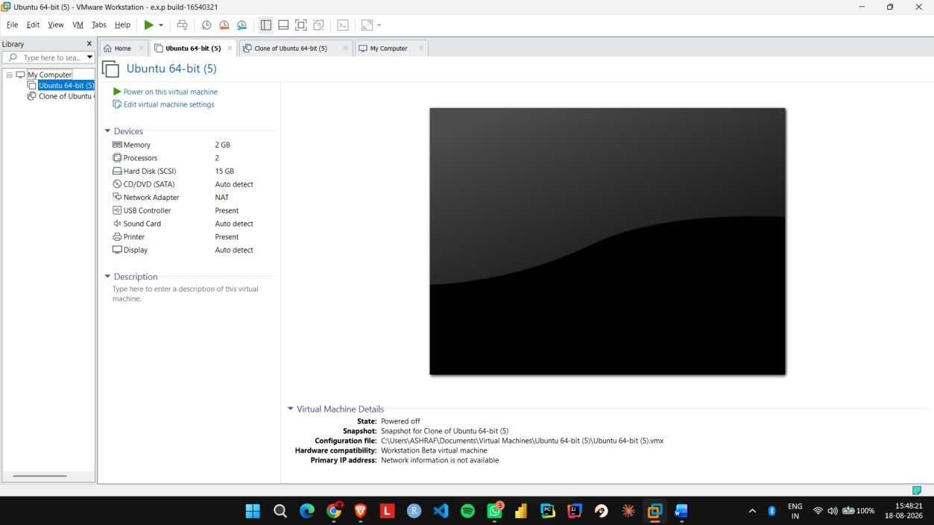

Step 2: Open VMware Workstation and select VM → Manage → Clone.

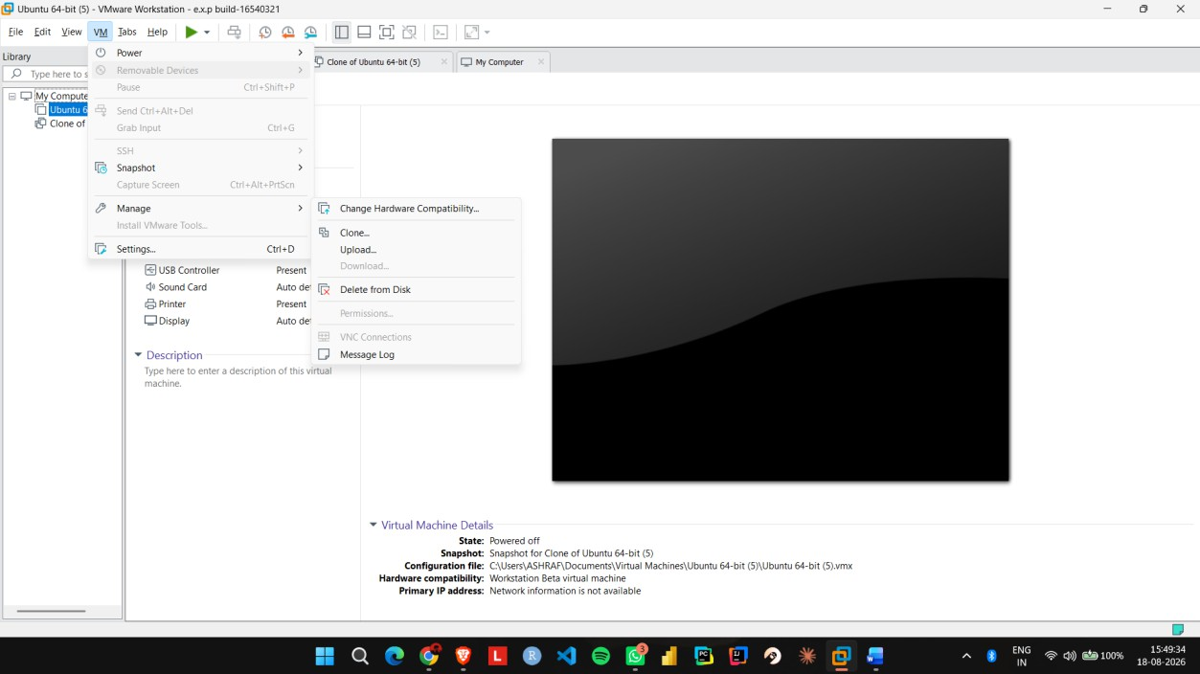

Step 3: Select the current state of the virtual machine as the cloning source.

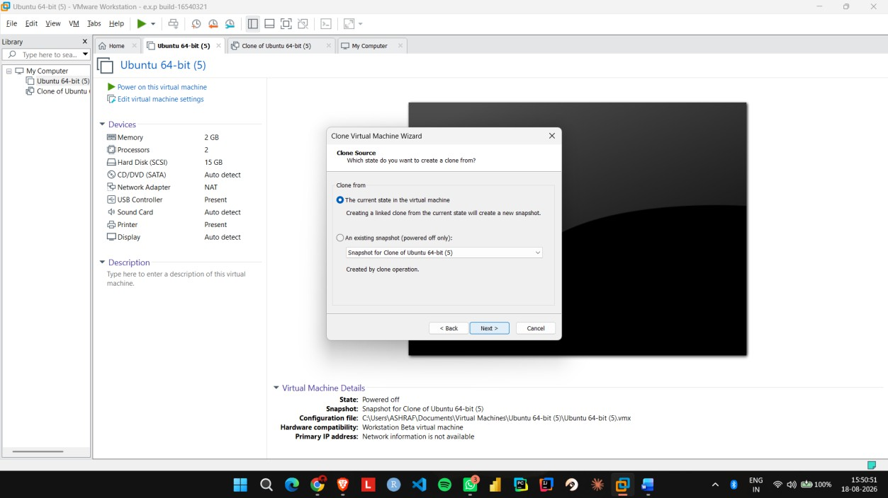

Step 4: Select Create a Full Clone and give the cloned VM a name such as Ubuntu_Clone.
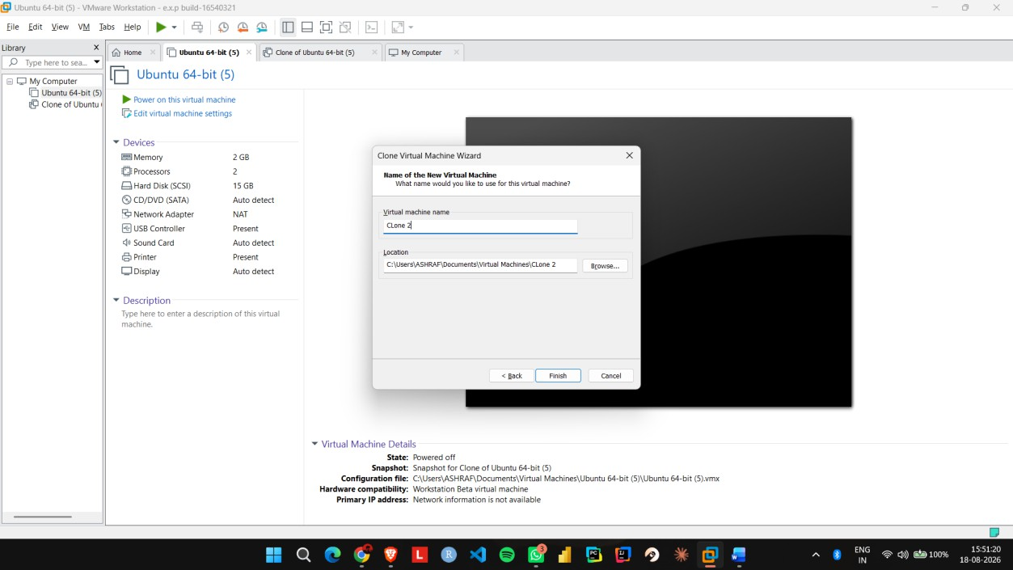

Step 5: Complete the cloning process and start the Ubuntu_Clone virtual machine.

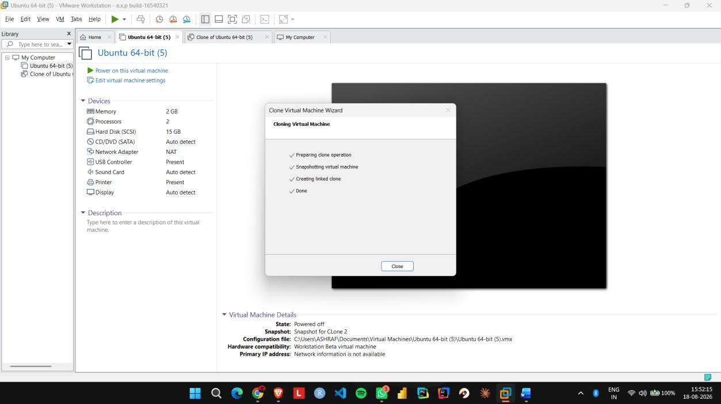
Step 6: Create a test file in the cloned VM and verify that it does not appear in the original Ubuntu VM.
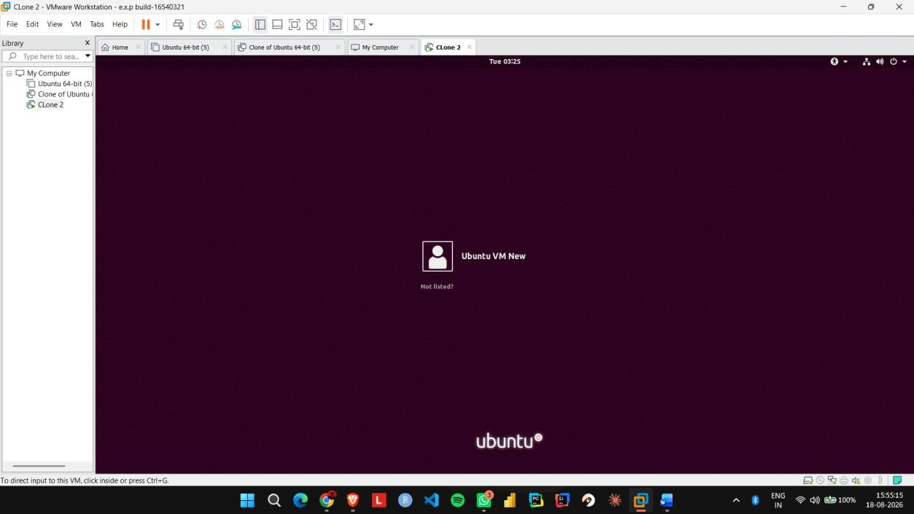

EXP NO 16: Change Hardware compatibility of a VM (Either by clone/create new one) which is already created and configured, using virtual box.

Aim:
To change the hardware configuration and compatibility of an existing virtual machine using VMware Workstation.

Procedure:
Step 1: Shut down the existing Ubuntu VM and open Edit virtual machine settings.
Step 2: Go to Hardware and change the memory from 2 GB to 4 GB. Step 3: Change the processor configuration from 1 CPU to 2 CPUs. Step 4: Open Options → Advanced and check the virtual machine's hardware compatibility settings.
Step 5: If required, use Manage → Change Hardware
Compatibility and select the required VMware hardware version. Step 6: Apply the changes, start Ubuntu, and verify that the modified hardware configuration works correctly.

IMPLEMENTATION:

Step 1: Shut down the existing Ubuntu VM and open Edit virtual machine settings.

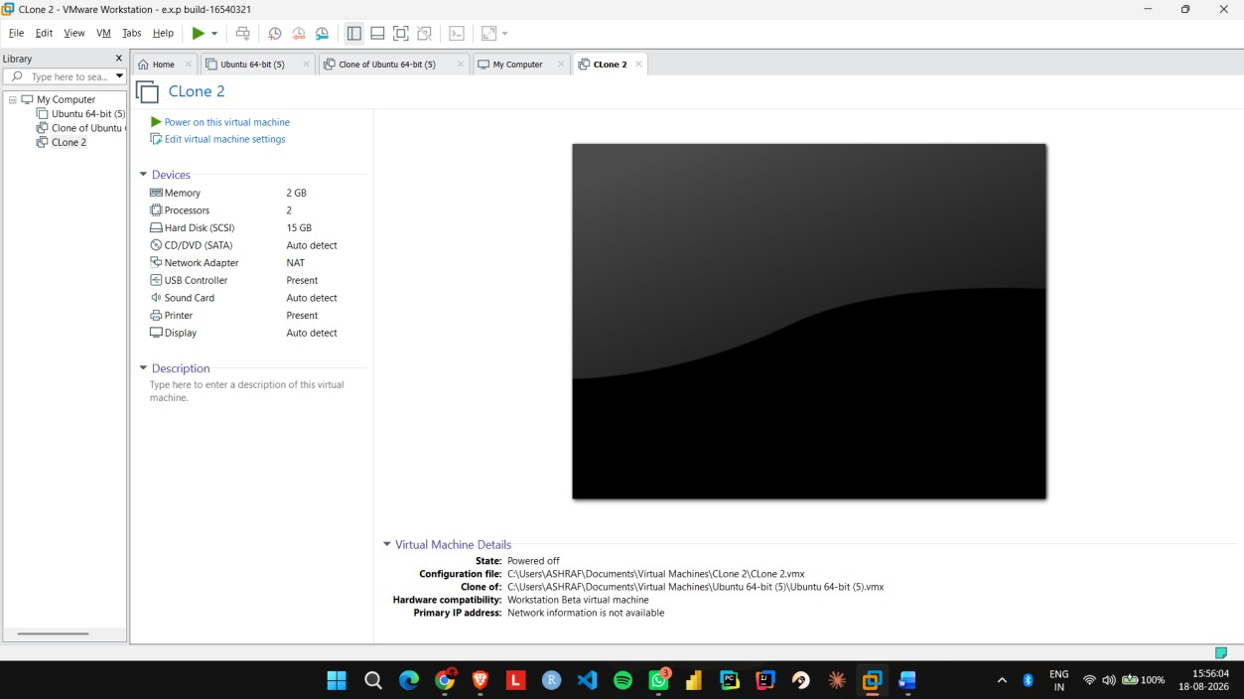

Step 2: Go to Hardware and change the memory from 2 GB to 4 GB.

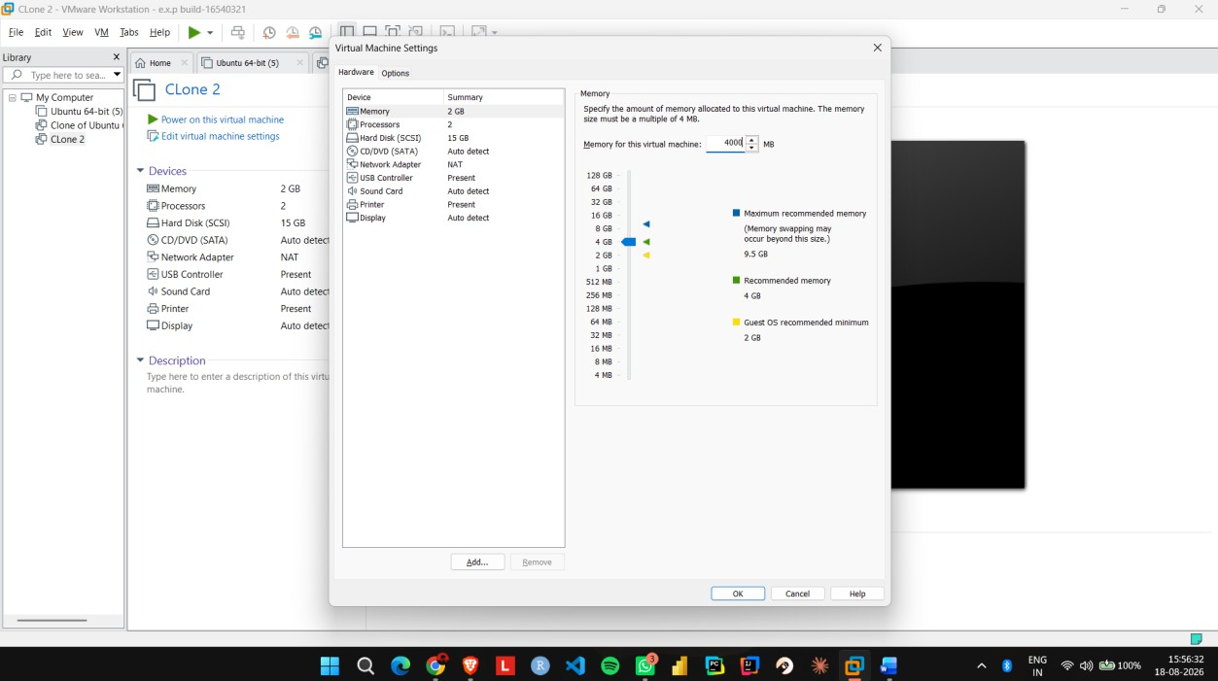

Step 3: Change the processor configuration from 1 CPU to 2 CPUs.
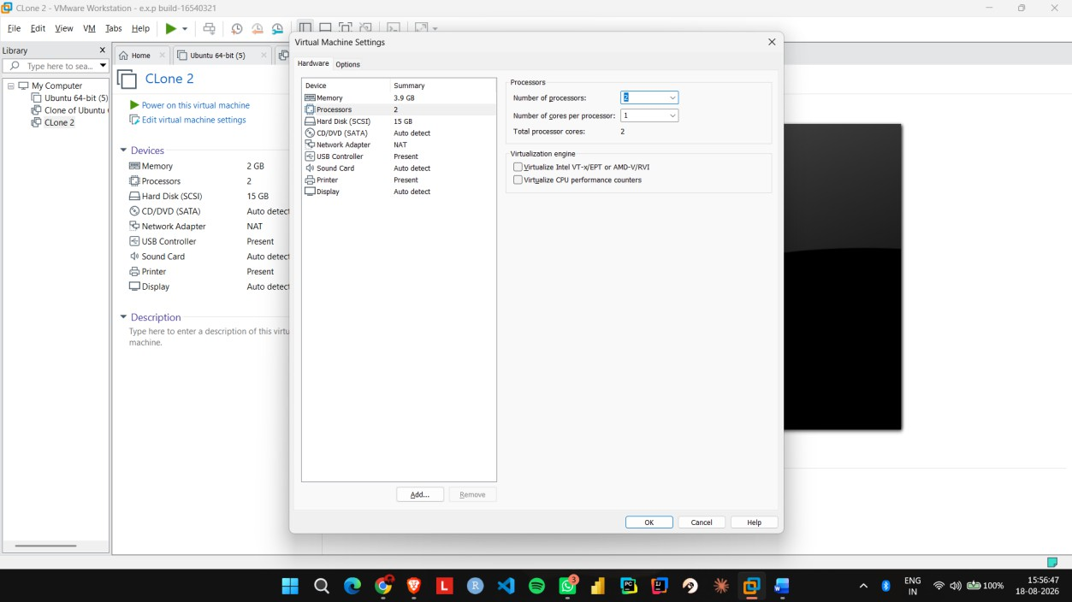

Step 4: Open Options → Advanced and check the virtual machine's hardware compatibility settings.
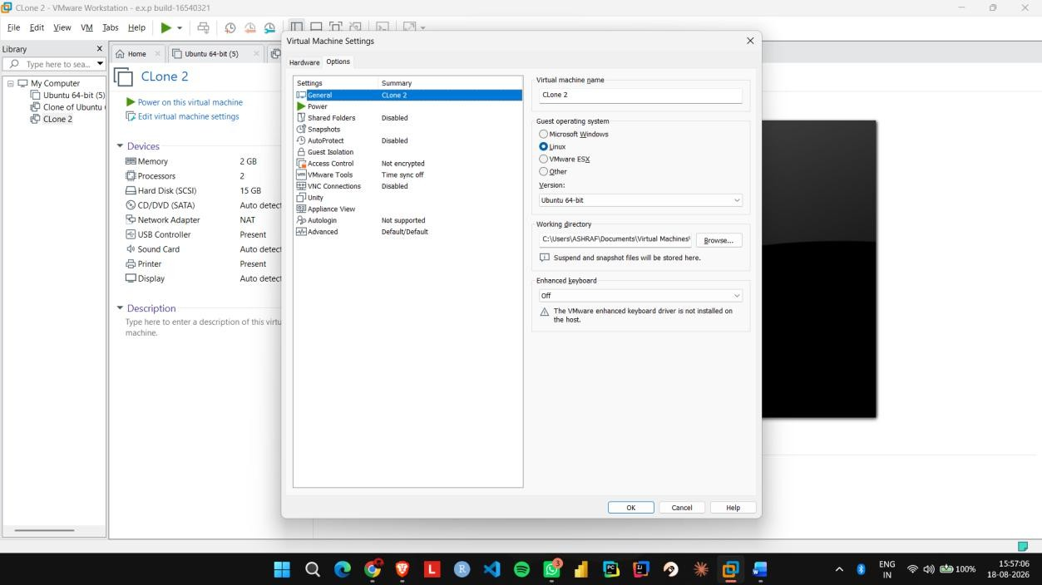

Step 5: If required, use Manage → Change Hardware Compatibility and select the required VMware hardware version.

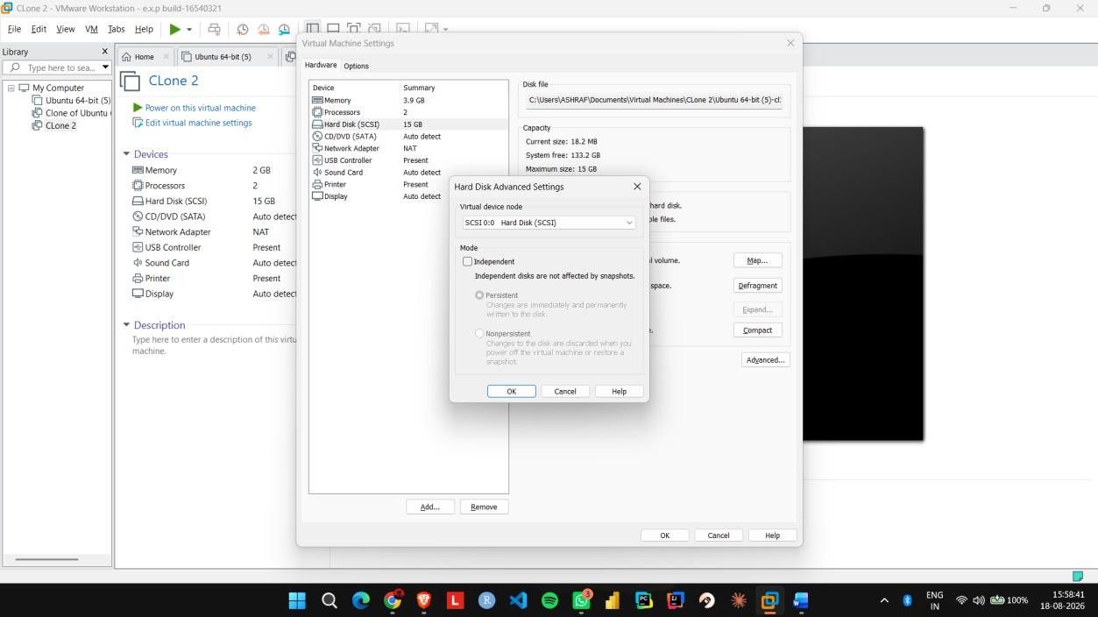

Step 6: Apply the changes, start Ubuntu, and verify that the modified hardware configuration works.


EXP NO 17: Demonstrate virtualization by Installing Type-2 Hypervisor in your device, create and configure VM image with a Host Operating system (EitherWindows/Linux), using VMware workstation.

Aim:
To demonstrate Type-2 virtualization by installing VMware Workstation and creating a configured Ubuntu virtual machine.

Procedure:
Step 1: Install and open VMware Workstation on the host operating system.
Step 2: Select Create a New Virtual Machine and choose the Typical configuration option.
Step 3: Select the Ubuntu ISO image and provide a suitable name for the virtual machine.
Step 4: Open Customize Hardware and configure 1 CPU, 2 GB RAM, and 15 GB disk storage.
Step 5: Select NAT for the network adapter and complete the virtual machine configuration.
Step 6: Start the VM, install Ubuntu, and verify that the guest operating system runs successfully inside VMware Workstation.

IMPLEMENTATION:

Step 1: Install and open VMware Workstation on the host operating system.

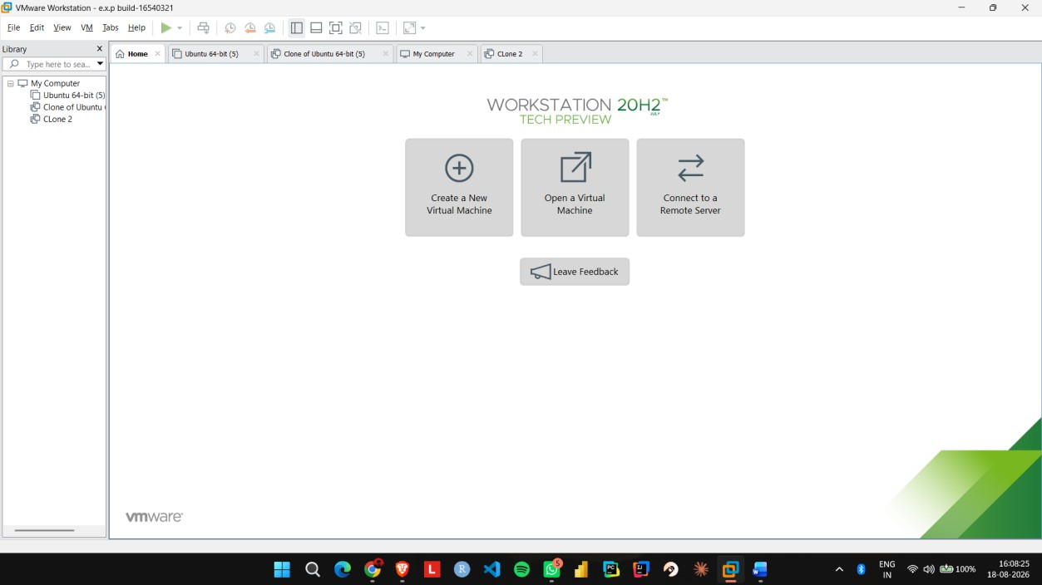
Step 2: Select Create a New Virtual Machine and choose the Typical configuration option.
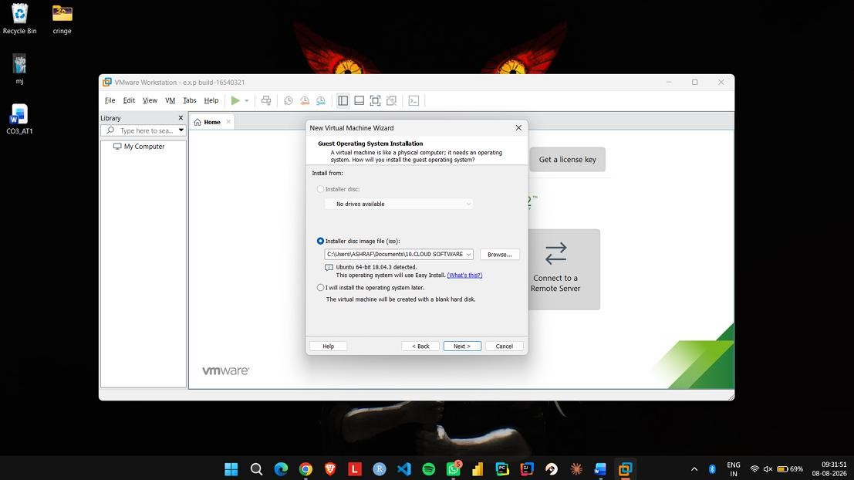

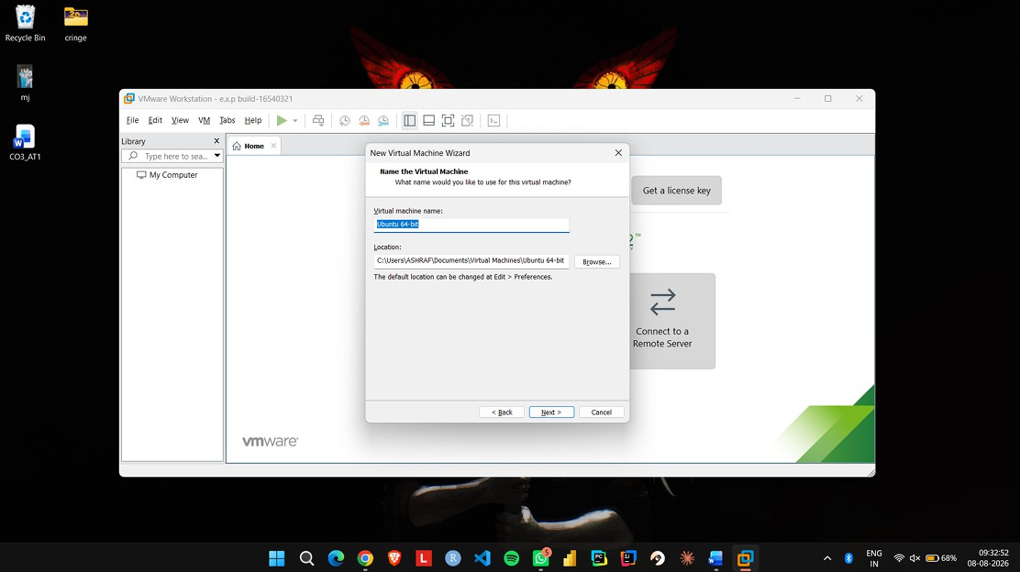
Step 3: Select the Ubuntu ISO image and provide a suitable name for the virtual machine.

Step 4: Open Customize Hardware and configure 1 CPU, 2 GB RAM, and 15 GB disk storage.

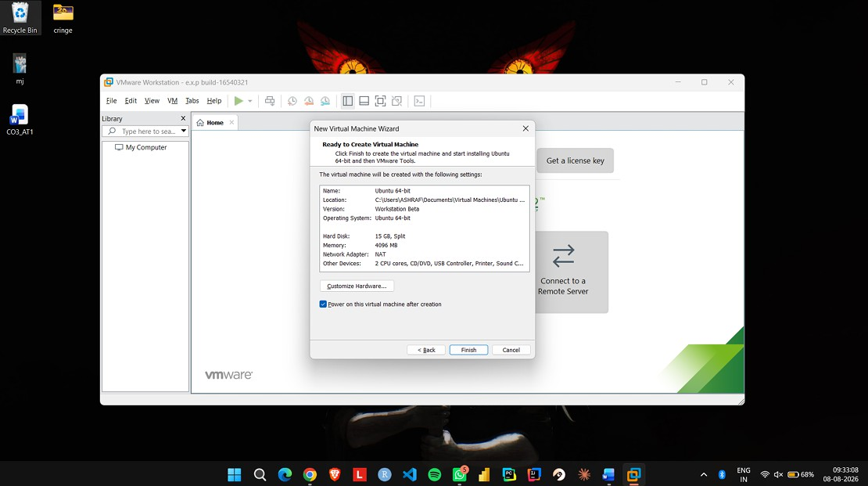

Step 5: Select NAT for the network adapter and complete the virtual machine configuration.
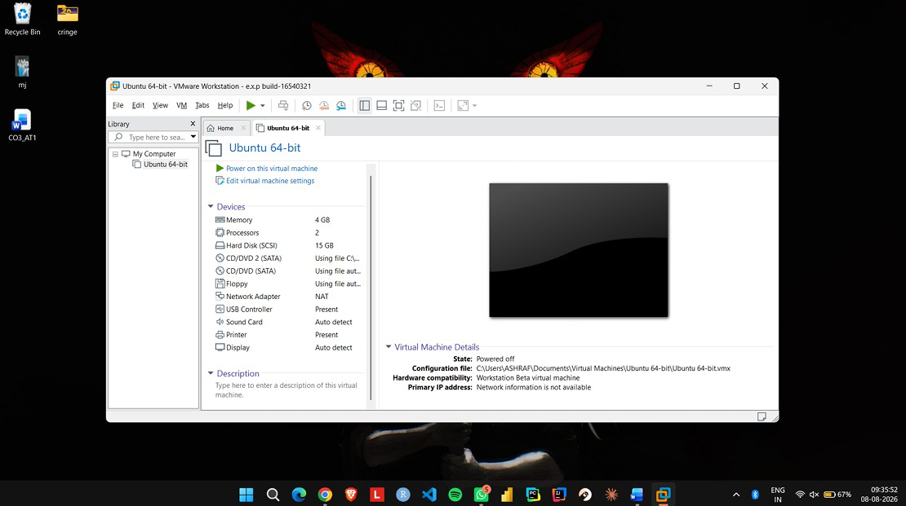
Step 6: Start the VM, install Ubuntu, and verify that the guest operating system runs successfully inside VMware Workstation.
